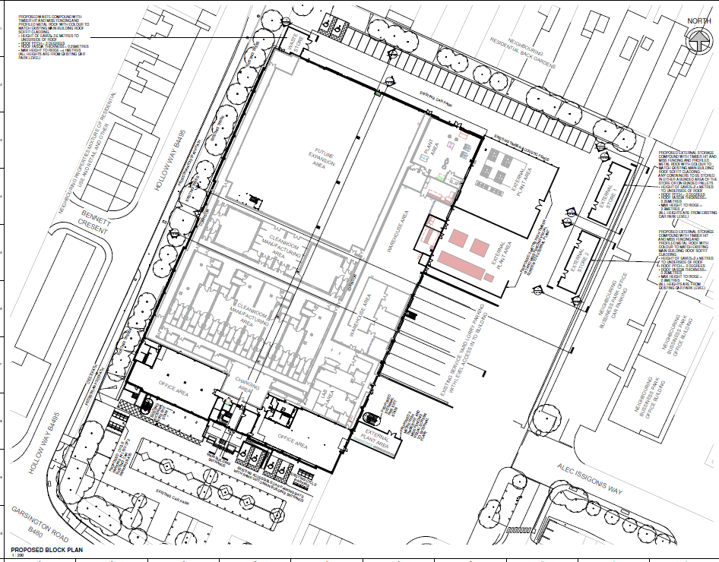

**Appendix 1**

19/01373/FUL – Former Royal Mail Sorting Office  
Proposed block plan